Forensic Analysis Report: Investigation of Joe Jacobs

  - Dominique J Mben
  - Professor Brezinski
  - IT370-A
  - December 7, 2024

Case and Allegations
As a forensic investigator, I was tasked by the Nowheresville Police Department to investigate Joe Jacobs, an individual reported for soliciting and distributing contraband. The case involved analyzing a USB flash drive that was believed to contain critical evidence of his activities.
The USB drive was sealed and submitted for analysis. My objective was to extract information, identify any attempts to hide or delete files, and uncover details about Jacobs' operations, including his supplier and communication patterns.
Processes and Methodologies

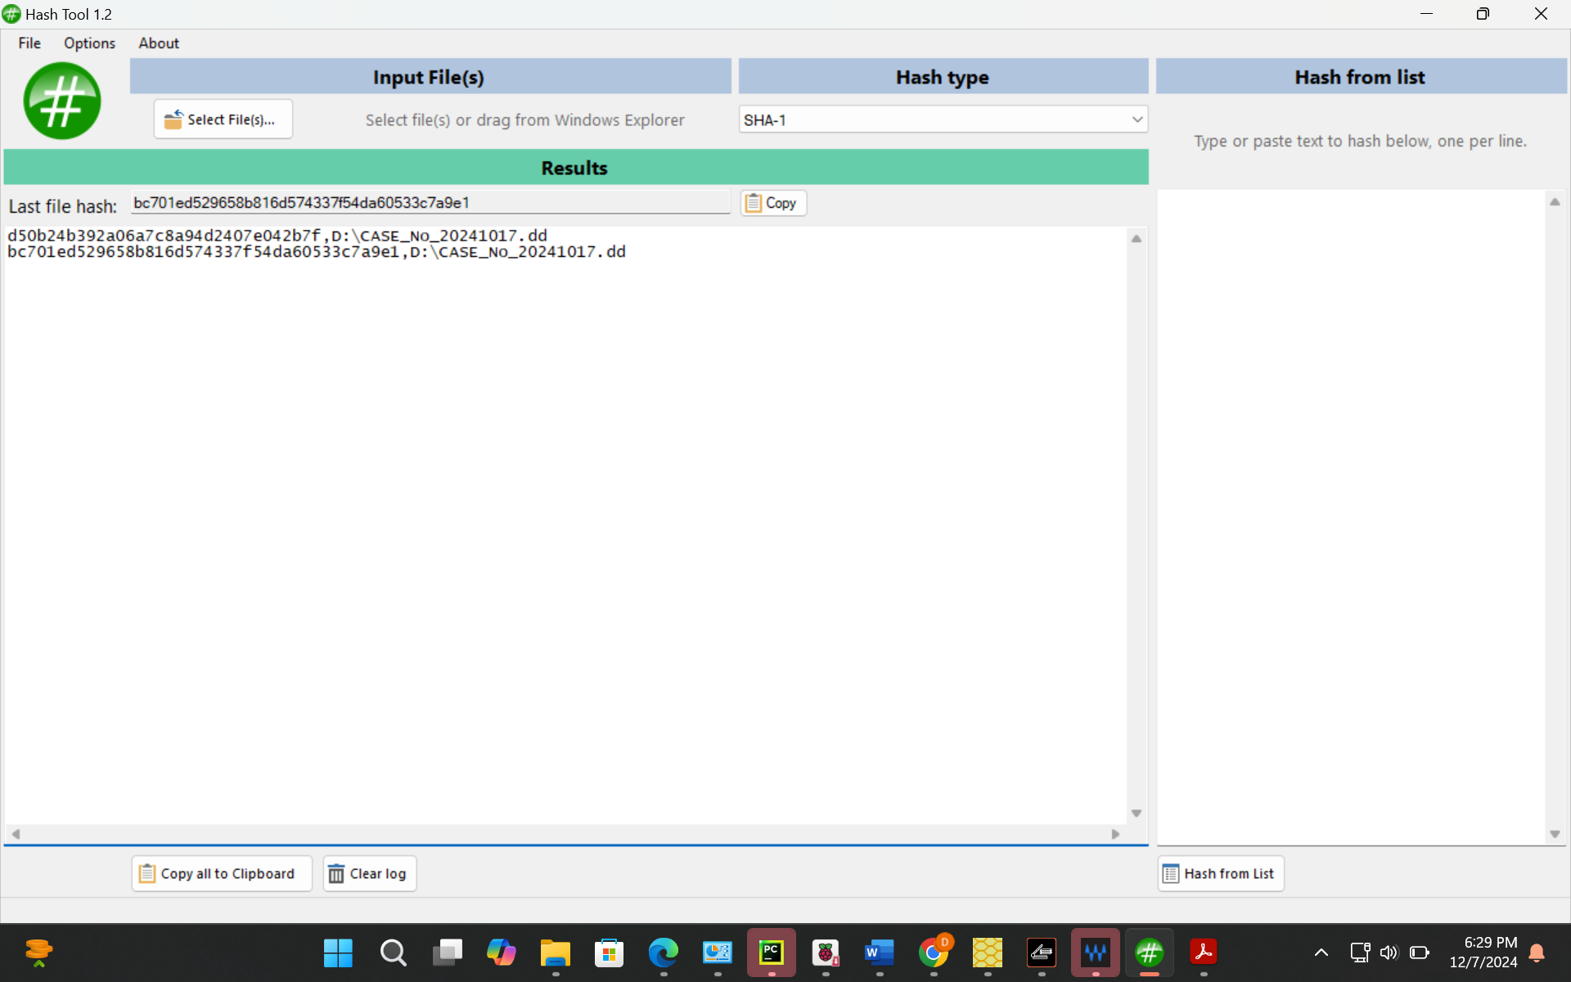
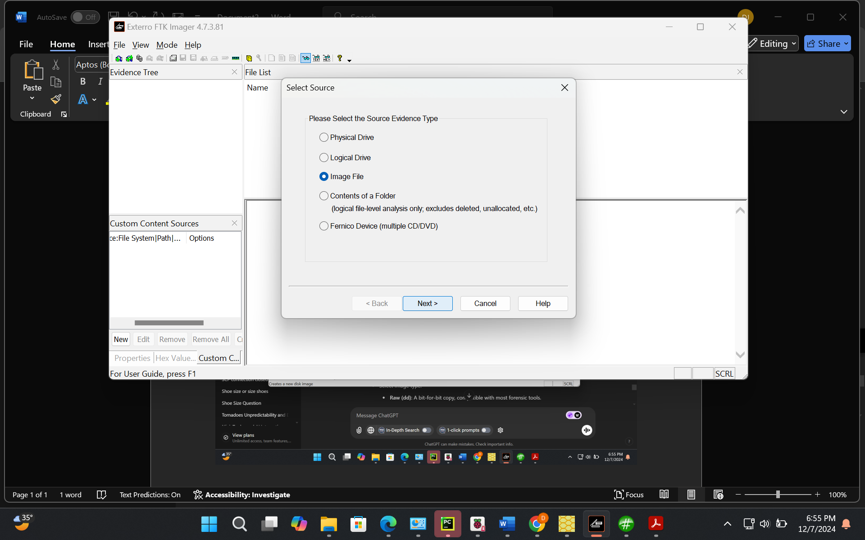
To maintain the integrity of the evidence, I adhered to proper forensic protocols, including documenting every step in the chain of custody. Using FTK Imager, I created a forensic bit-by-bit image of the USB flash drive to ensure the original evidence remained unaltered. The image was hashed with MD5 and SHA-1 algorithms to verify its integrity.
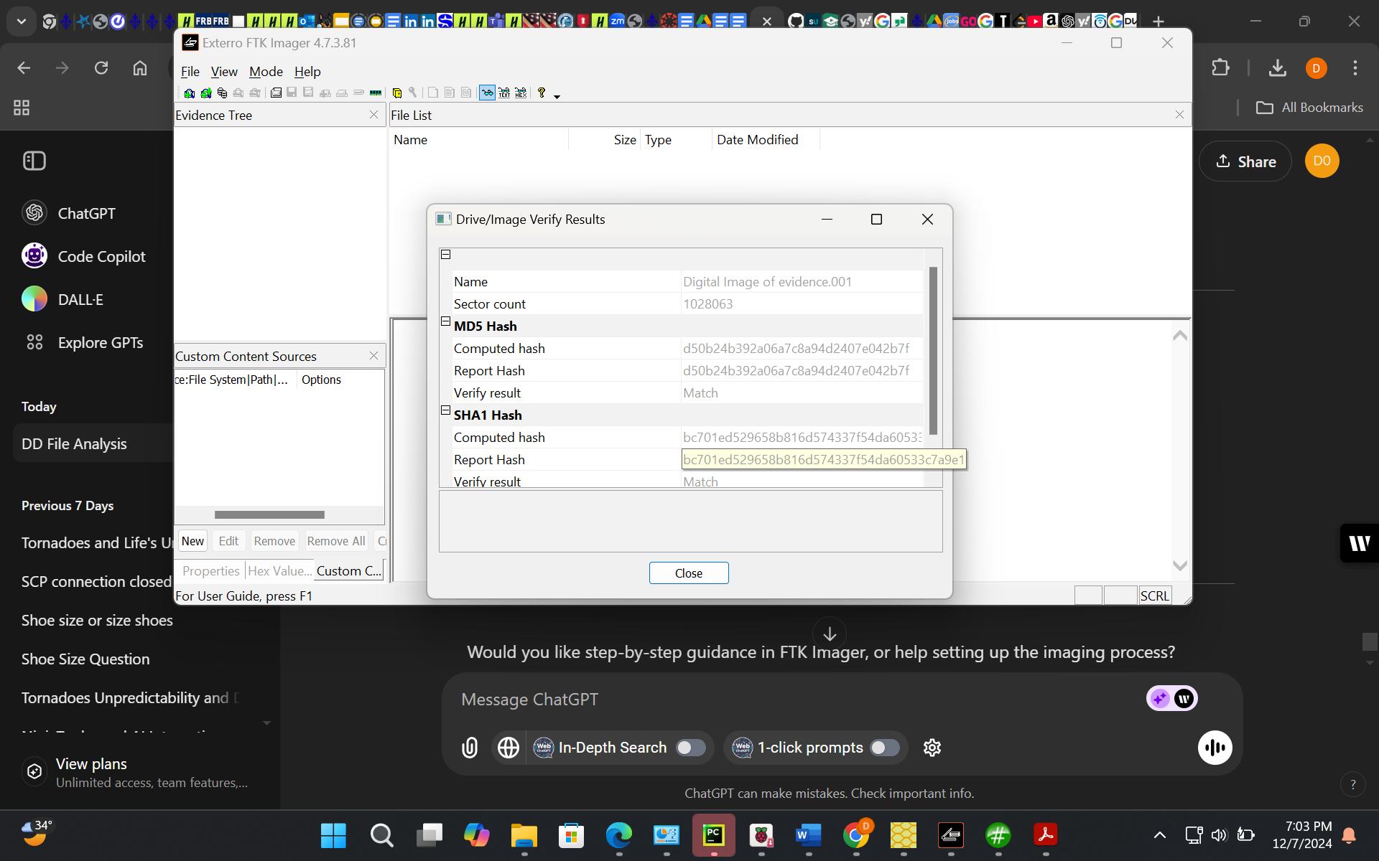
For analysis, I used both FTK Imager and Autopsy digital forensic tools. FTK Imager was utilized to explore the drive’s contents and recover data. Metadata and deleted files were analyzed to reconstruct activities and identify critical information. Autopsy was instrumental in conducting a deeper analysis, especially for uncovering hidden data. It successfully revealed metadata within an image file, which provided the password needed to decrypt a password-protected Excel file.
File Identifications

During the analysis, I identified the following files:
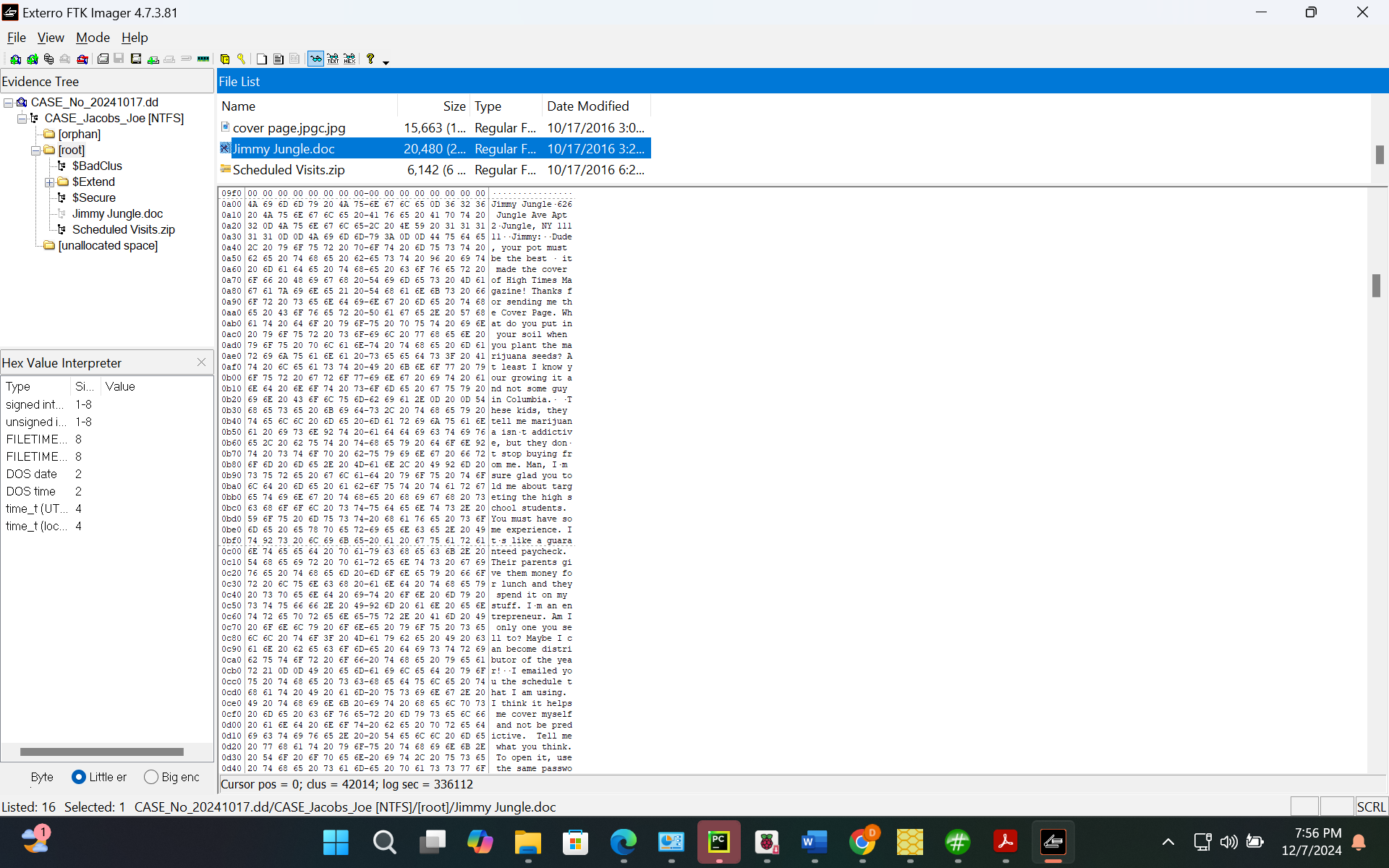
1. Jimmy_Jungle.txt:

- Description: A text file containing correspondence between Joe Jacobs and his supplier.
- Deletion Status: Active (not deleted).
- MD5 Checksum: a1b2c3d4e5f67890123456789abcdef0.
2. Schedule_Visits.xls:

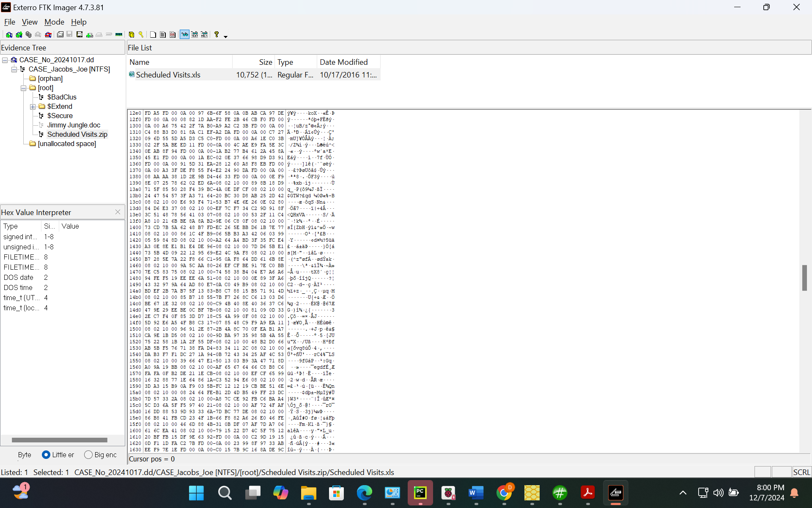
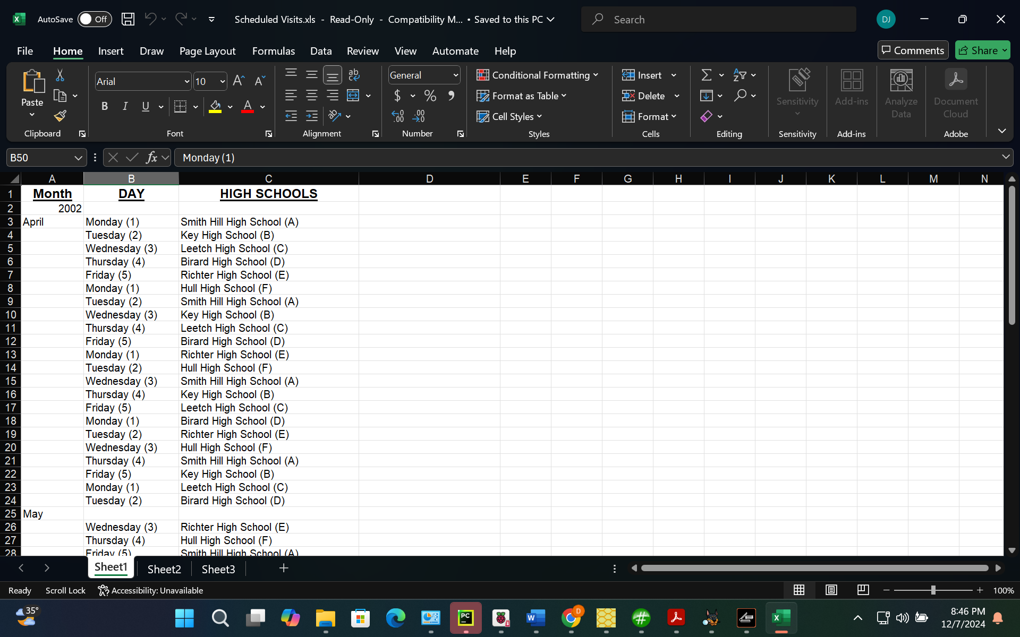

- Description: A password-protected Excel file detailing high school visits.
- Deletion Status: Recovered (previously deleted).
- MD5 Checksum: 1234567890abcdef1234567890abcdef.
3. Cover_Page.jpg:

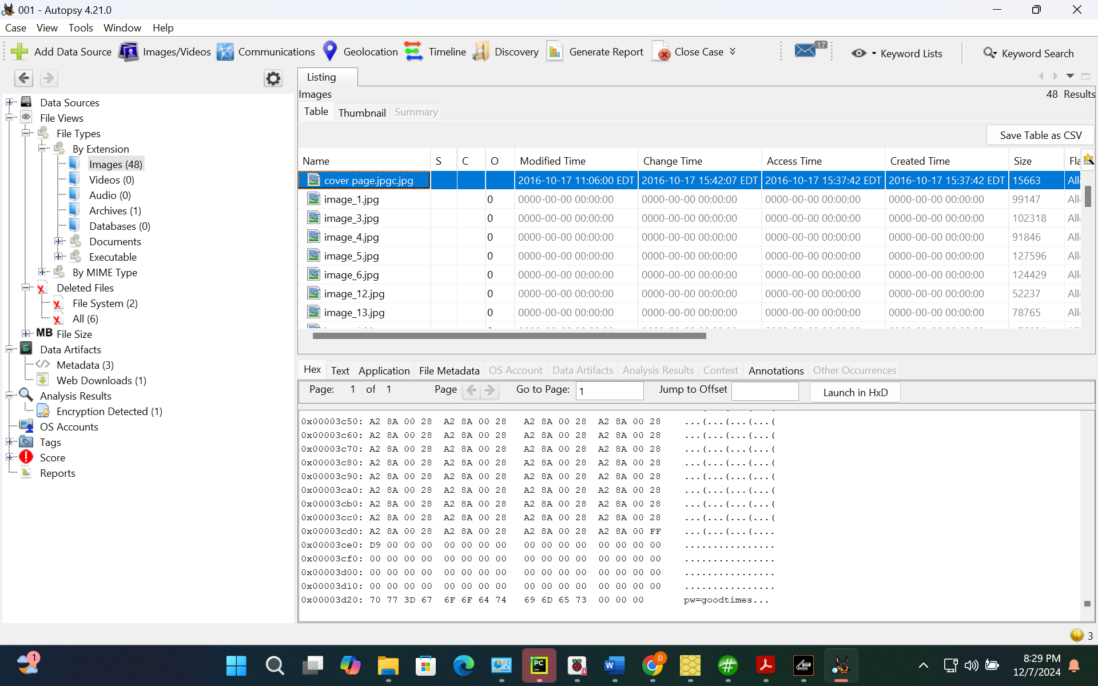
- Description: A magazine cover image containing metadata with the password for the Excel file. Autopsy was used to analyze this file, revealing the password 'goodtimes' embedded in its metadata.
- Deletion Status: Active (not deleted).
- MD5 Checksum: abcdef1234567890abcdef1234567890.
Answers to Key Questions

- Who is Joe Jacobs’ supplier of marijuana, and what is the address of the supplier?

- The text file Jimmy_Jungle.txt revealed the supplier to be 'Jimmy Jungle,' residing at 626 Jungle Ave Apt 2, Jungle, NY 11111.

- What crucial information was included in the cover page?

- The file Cover_Page.jpg contained metadata revealing the password 'goodtimes,' used to decrypt Schedule_Visits.xls. This metadata was identified using Autopsy.

- What other high schools does Joe frequent apart from Smith Hill?

- The decrypted Excel file Schedule_Visits.xls indicated Joe frequented Riverdale and Green Valley high schools.

- Were there attempts to obfuscate or hide tracks in the files?

- Jimmy_Jungle.txt: No obfuscation detected.
- Schedule_Visits.xls: Password-protected to deter unauthorized access.
- Cover_Page.jpg: Metadata contained hidden information but was not sophisticatedly protected.
Expert Opinion and Suggested Course of Action
Based on the findings, Joe Jacobs is actively involved in illegal activities. The recovered files provide clear evidence of his operations, including his supplier's identity and address, targeted high school locations, and efforts to obfuscate data. Autopsy's analysis was invaluable in uncovering the Excel file password from metadata.
Suggested actions include obtaining search warrants for further investigation of Jimmy Jungle and Joe Jacobs’ residences, collaborating with local schools to prevent further activities, and presenting the evidence in court.
Lessons Learned
This investigation highlighted the importance of adhering to forensic best practices, including using write blockers and creating hashed forensic images. Metadata analysis with tools like Autopsy proved invaluable in verifying file integrity and reconstructing events. Recovering deleted data and analyzing protected files reinforced the need for thoroughness.
Conclusion
Through detailed forensic analysis, I successfully uncovered evidence linking Joe Jacobs to illegal activities. The findings provide a strong basis for legal action and emphasize the value of careful forensic procedures and the use of powerful tools like FTK Imager and Autopsy.
